**Joystick Kit Quick Start Guide**

For this first test, we want to see if we can distinguish between different body positions with different users.  This test is intended to work with a computer/laptop to play simple arcade games.  As an example of what we are trying to accomplish, please watch this [video](https://youtu.be/SsOqFFKt7dk).

1. **Pair the joystick with a computer via Bluetooth.** Turn on or plug in the Atom(grey box).  Next, in your computer settings, try to search for a bluetooth device (It might be called something like ESP32 Keyboard/Mouse) and connect it.  Keep the Atom turned on for the entire duration of use.
2. **Turn on the Joystick attached to the wristband.**  Since the battery life is short on these devices, please keep them plugged in for the test. (Hopefully, we can send you some longer USB cables.).  Wear the joystick on your wrist tightly so it doesn’t move.  The simplest test case would be to manipulate the joystick with your hand if possible.  Another option is to tape it to another part of the body.  For this unit, no buttons need to be pressed (except the on/off button).

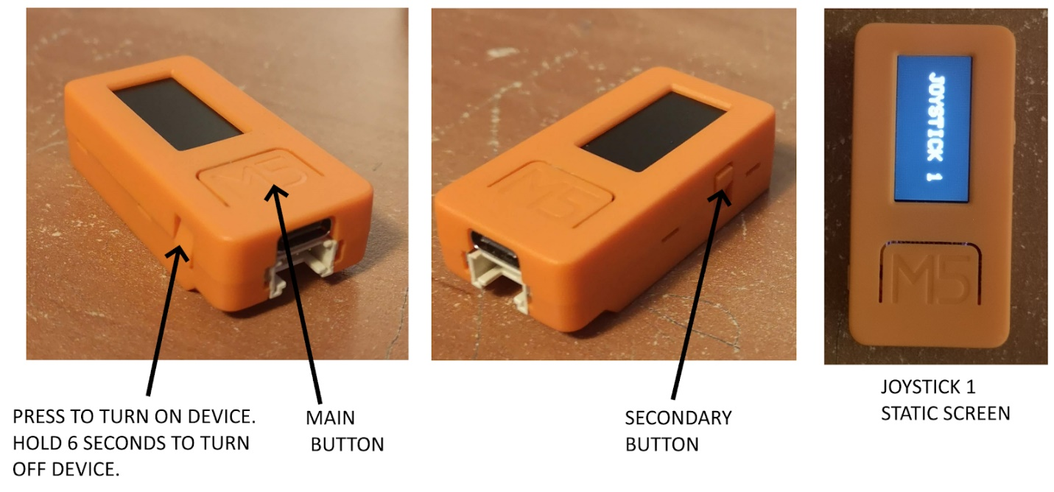

1. **Turn on the second orange device.** This device is for calibration and changing game modes.  WHen turned on, the interface should appear like the image below.

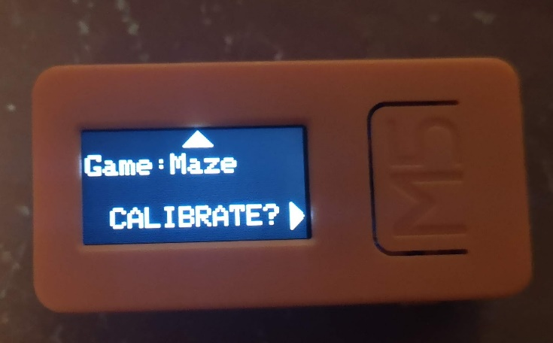

The secondary small button is used to change game modes.  By pressing the secondary button, the text will change as seen in the next image.

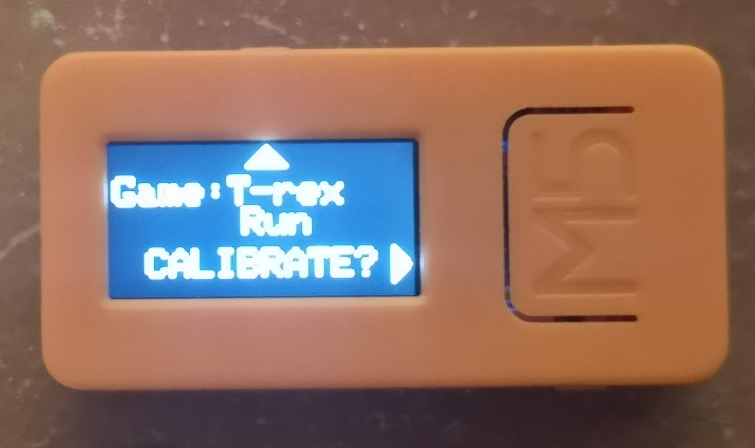

Anytime the user changes position or the device is given to a new user, the unit needs to be recalibrated.  When the big main button is pressed, it will start the calibration cycle and the screen will be display this:

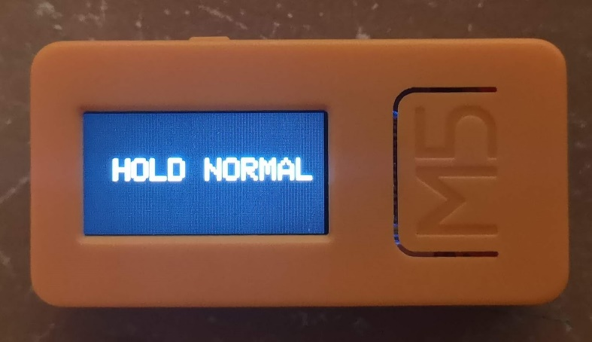

The text will give prompts of what positions the user should hold their hand.  The calibration cycle goes from “HOLD NORMAL”, “HOLD LEFT”, “HOLD RIGHT”, “HOLD UP”, then “HOLD DOWN”.  Hold normal should be a neutral, comfortable resting position.  The next four directions are dependent on the user’s mobility.  They don’t have to be in the left, right, up, and down directions, but if possible, try to move in these directions as it will make the games more intuitive.

Once the user is in the position, ask them to hold steady.  Then, press the main button and you will see the screen flash green.  After about 2 seconds, the screen will return back to normal and the next prompt will appear.

Game Modes correspond to the following games and actions:

**Maze:** <https://www.happyclicks.net/maze-games/index.php>

The positions left, right, up, and down are used to navigate through the mazes

**Pacman/Snake:**    <https://elgoog.im/snake/>          <https://elgoog.im/pacman/>

Similar to the Maze controls, but the response time is a bit faster.

**Space Invaders:** <http://thesimplearcade.com/play/space-invaders.html>

Left and right correspond to the side-to-side movement.  Up corresponds to shooting

**T-rex run:** <https://elgoog.im/t-rex/>

Left corresponds to a T-rex jump.

The maze game is the simplest and most likely to work for users as it is not dependent on time.  If it gets boring, try to see if the other games work as well.  If an individual does not have line of sight to play these games, please set the game mode to maze and test using a keyboard testing website such as this: <http://en.key-test.ru/>.  See if users can correctly hit different arrow keys, which will be highlighted in blue when hit.